Technical Data Sheet
(TDS)
Product information
Product Name | : | Redispersible Polymer Powder (RDP/VAE)
Product application | ： | RDP (TR-680R) Redispersible polymer powder is a water-soluble redispersible powder, a vinyl acetate-ethylene polymer, suitable for outdoor plastering mortar and exterior walls flexible putty.  Advantages:  1. Improve the impact resistance, durability and wear resistance.  2. Improve the bonding strength and cohesion.  3. Improve the weather resistance and freeze-thaw resistance and prevent mortar cracking.  4. Improve the hydrophobicity and reduce water absorption.  5. Improve the bending strength and flexural strength.  Application range:  1. Flexible putty for exterior walls  2. Lacquer primer putty  3. Anti-crack plaster putty  4. Tile adhesive  5. Exterior wall external insulating plastering mortar
Technical Specification
Appearance | : | White or off white flowable powder
Odor | : | Weak odor
Model |  | TR-680R
Composition | : | Vinyl acetate, ethene polymer |  | 99.2%
Test items |  | Standard requirement | Test result | evaluate
Exterior |  | No color difference,impurities, agglomeration |  | qualified
Bulk density, kg/m³ |  | 550±50 | 525 | qualified
Content,% |  | ≥98.0 | 99.4 | qualified
PH |  | 5~9 | 7.5 | qualified
Ash |  | 12±2 | 12.6 | qualified
Tg |  | -9℃ | -9℃ | qualified
MFFT |  | 0℃ | 0℃ | qualified
Storage Information
Storage Temperature(°C) and condition | : | Room temperature, cool and dry place.
Transport Information
Marine Pollutant | : | No
ADR/RID | : | Not Dangerous Goods
IMDG | : | Not Dangerous Goods
IATA | : | Not Dangerous Goods
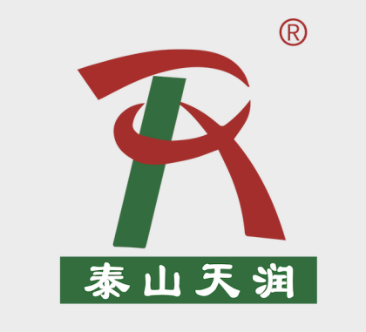 |  | Taian Tianrun Gome New Material Co., Ltd.  Add: Feicheng City, Taian City, Shandong Province,China  Contact: Leo Liu  MOB/WA: +86 18905481653  Email: leo@rdptianrun.com

